Expt. no: 5 Date:

Creating a new symbol for IC LM741 using KiCAD 8

Objective: To create a new symbol for IC LM741

Software: KiCAD 8

Procedure:
- Choose the datasheet for IC LM741. Refer to the pin configuration and functions section.
- Create a new symbol library:
  - Open the Symbol Editor from the Project Manager.
  - Click File → New Library, and select Project. Choose a name for the new library and save it in the project directory.
  - The empty new library is now selected in the Libraries pane at left and has been automatically added to the project library table.
- Create a new symbol in the new symbol library:
  - With the new library selected in the Libraries pane, click File → New Symbol…​. In the Symbol name field, enter the part number. Choose the reference designator. All other fields can remain as the defaults.
  - In the Libraries pane, the symbol now appears under the new library. In the canvas, a cross indicates the center of the footprint, and text has been added for the symbol name and reference designator. For now, move the text away from the center of the footprint to get it out of the way.
  - Start drawing the symbol by adding a pin. Click the Add a pin button on the right toolbar. The Pin Properties dialog will appear. According to the datasheet, Set Pin name, Pin number, Electrical type, and Orientation as necessary. Click OK, then click on the canvas to place the pin. Repeat for all pins as per the datasheet. Arrange the pins and draw a shape as necessary to create the body of the symbol.
  - Click on File → Symbol Properties… Enter the Value as IC LM741 appended with your initials, insert the URL of the datasheet, and write the description and keywords of the device as necessary.

Implementation:

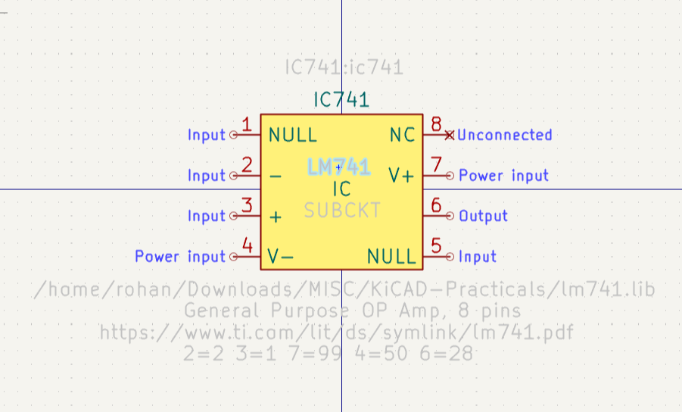

Fig. 5.1 Symbol Created

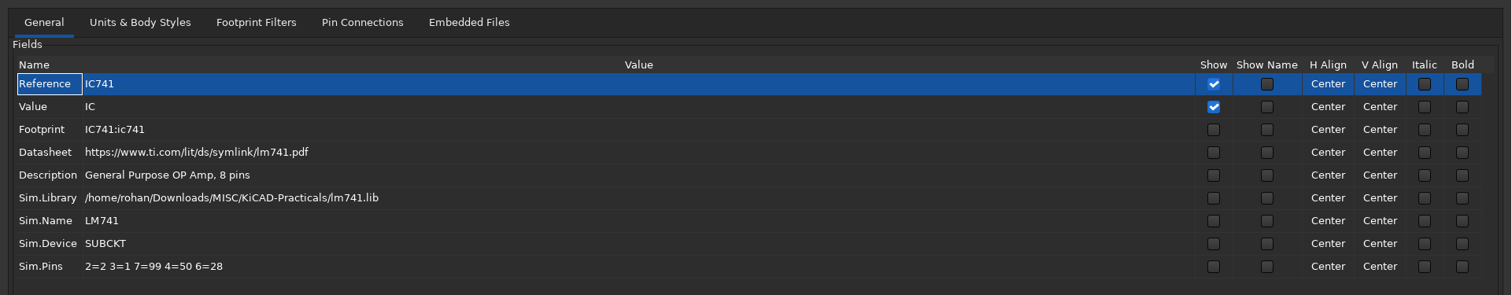

Fig. 5.2 Symbol Properties

Challenges: The main challenge I faced was determining the validity of the symbol I created. To verify this, I imported a valid SPICE model into the symbol and ran a simulation using a simple inverting amplifier circuit. This hands-on approach helped me confirm that the symbol functioned correctly within the simulated environment.

Conclusion: The following objectives were successfully achieved:
- Creation of a new symbol for IC LM741
- Setting the properties for the symbol designed

